**GROUP 8**

**(Database Project on Indian Premier League Players’ Records)**

Group Members:

* B16CS024 (Devansh Maurya)
* B16CS025 (Ali Akbar)
* B16CS026 (Abhay Shekhar Yadav)

Database Name: ipl

Tables:

* player_personal
* player_batting
* player_bowling



**SQL Query to create the table:**

CREATE TABLE `player_personal` (

`first_name` varchar(20) NOT NULL,

`last_name` varchar(20) NOT NULL,

`date_of_birth` date DEFAULT NULL,

`birth_city` varchar(20) DEFAULT NULL,

`birth_state` varchar(20) DEFAULT NULL,

`position` varchar(30) NOT NULL,

`team` varchar(30) NOT NULL,

`match_played` smallint(5) UNSIGNED NOT NULL

) ENGINE=InnoDB DEFAULT CHARSET=latin1;

ALTER TABLE `player_personal`

ADD PRIMARY KEY (`first_name`,`last_name`);



**SQL Query to create the table:**

CREATE TABLE `player_batting` (

`first_name` varchar(20) NOT NULL,

`last_name` varchar(20) NOT NULL,

`innings` smallint(5) UNSIGNED NOT NULL,

`not_out` smallint(5) UNSIGNED NOT NULL,

`runs_scored` smallint(5) UNSIGNED NOT NULL,

`highscore` smallint(5) UNSIGNED NOT NULL,

`ball_faced` smallint(6) UNSIGNED NOT NULL,

`hundred` smallint(5) UNSIGNED NOT NULL,

`double_hundred` smallint(5) UNSIGNED NOT NULL,

`fifty` smallint(5) UNSIGNED NOT NULL,

`four` smallint(5) UNSIGNED NOT NULL,

`six` smallint(5) UNSIGNED NOT NULL

) ENGINE=InnoDB DEFAULT CHARSET=latin1;

ALTER TABLE `player_batting`

ADD KEY `FK_player_batting` (`first_name`,`last_name`);

ALTER TABLE `player_batting`

ADD CONSTRAINT `FK_player_batting` FOREIGN KEY (`first_name`,`last_name`) REFERENCES `player_personal` (`first_name`, `last_name`) ON DELETE CASCADE ON UPDATE CASCADE;



**SQL Query to create the table:**

CREATE TABLE `player_bowling` (

`first_name` varchar(20) NOT NULL,

`last_name` varchar(20) NOT NULL,

`innings` smallint(5) UNSIGNED NOT NULL,

`ball` smallint(5) UNSIGNED NOT NULL,

`runs_given` smallint(5) UNSIGNED NOT NULL,

`wicket` smallint(5) UNSIGNED NOT NULL,

`fifer` smallint(5) UNSIGNED NOT NULL,

`tenfer` smallint(5) UNSIGNED NOT NULL

) ENGINE=InnoDB DEFAULT CHARSET=latin1;

ALTER TABLE `player_bowling`

ADD KEY `FK_player_bowling` (`first_name`,`last_name`);

ALTER TABLE `player_bowling`

ADD CONSTRAINT `FK_player_bowling` FOREIGN KEY (`first_name`,`last_name`) REFERENCES `player_personal` (`first_name`, `last_name`) ON DELETE CASCADE ON UPDATE CASCADE;

**Graphical User Interface:**

The project is also supported by a GUI for querying the database, the source code for which is available on the following link:

[GitHub - Devansh-Maurya/SEM-4-Database-Project: A database project on storing records of IPL players in a database](https://github.com/Devansh-Maurya/SEM-4-Database-Project)

**Queries:**

Following are some of the queries that can be run on the database:

1. Who are the players with the most runs?

SQL Query: SELECT first_name, last_name, runs_scored FROM player_batting ORDER BY runs_scored desc;

On running the query using the GUI, following result was obtained

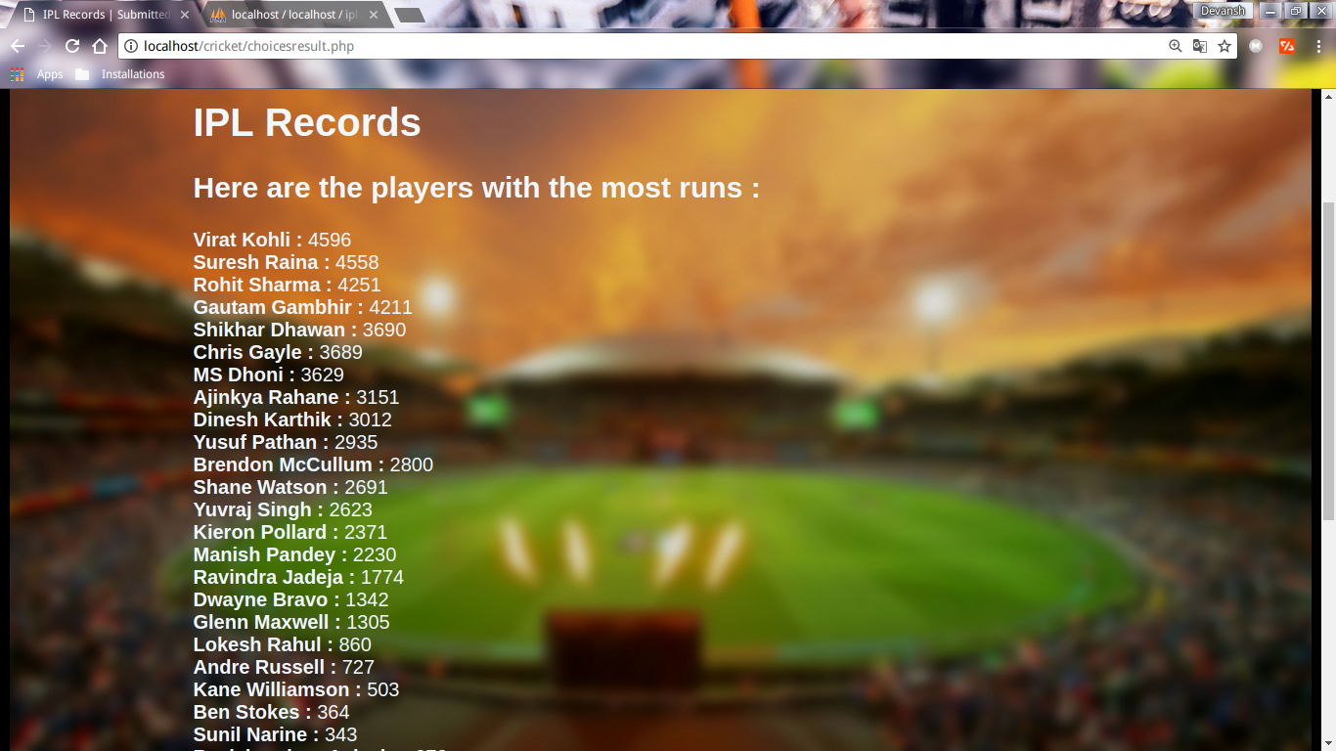

1. Who are the players with the most wickets?

SQL Query: SELECT first_name, last_name, wicket FROM player_bowling ORDER BY wicket desc;

On running the query using the GUI, following result was obtained:

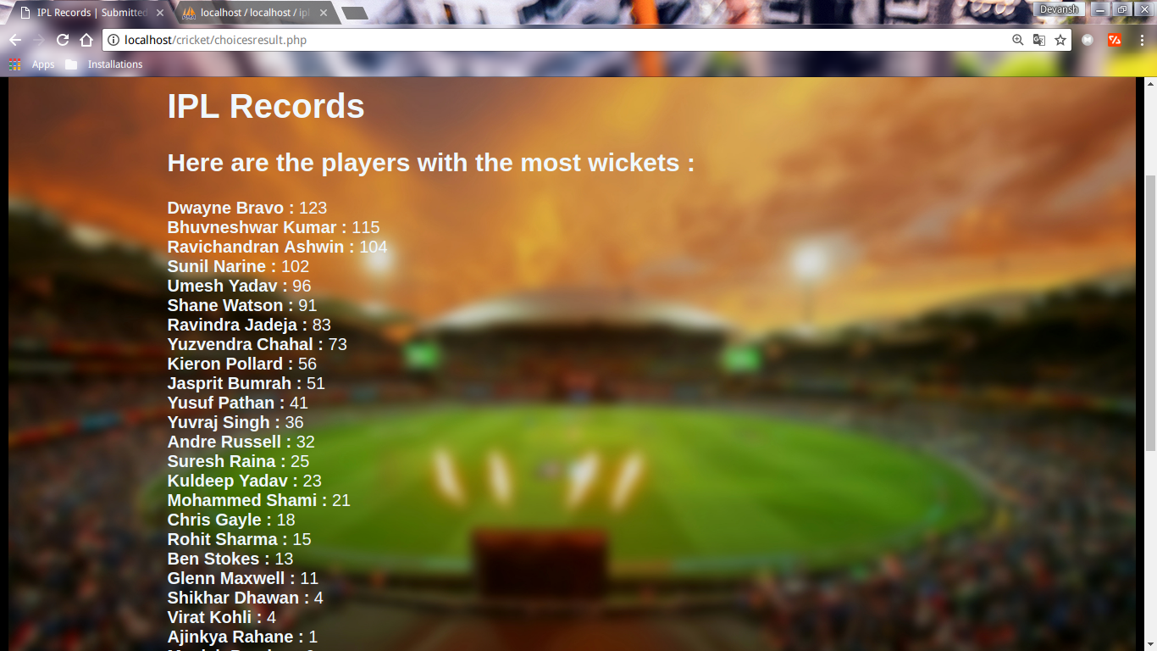

1. Who are the players with the best batting strike rate?

SQL Query: SELECT first_name, last_name, runs_scored/ball_faced*100 AS strike_rate FROM player_batting ORDER BY strike_rate desc;

On running the query using the GUI, following result was obtained:

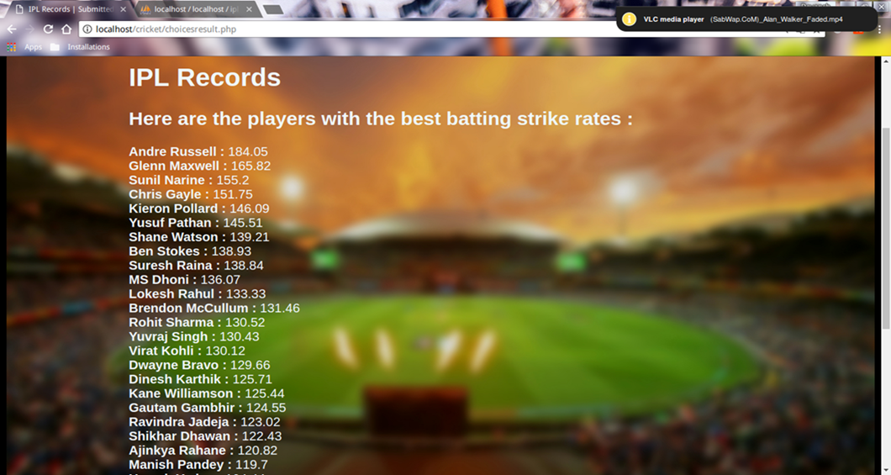

1. Who are the players with the best batting average?

SQL Query: SELECT first_name, last_name, runs_scored/(innings - not_out) AS average FROM player_batting ORDER BY average desc;

On running the query using the GUI, following result was obtained:

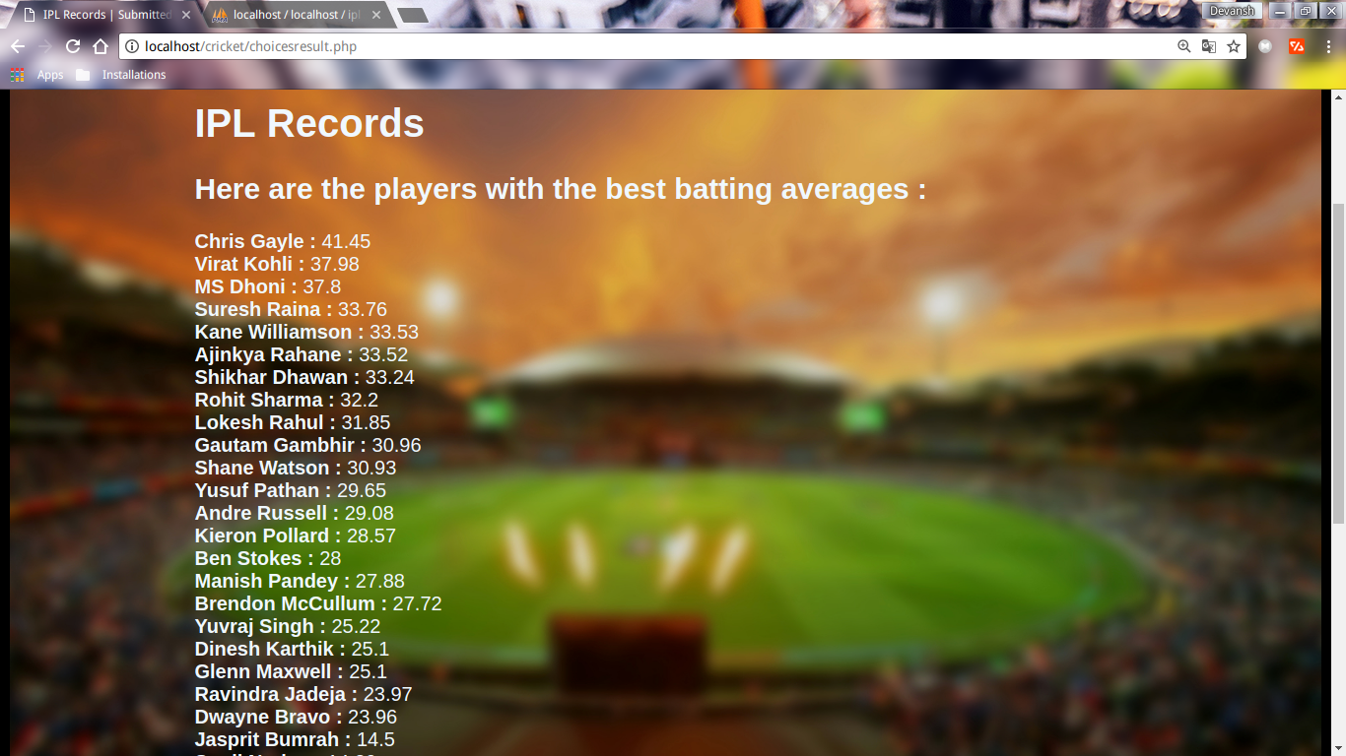

1. Who are the players with the best economy?

SQL Query: SELECT first_name, last_name, runs_given/ball*6 AS economy FROM player_bowling ORDER BY economy ;

On running the query using the GUI, following result was obtained:

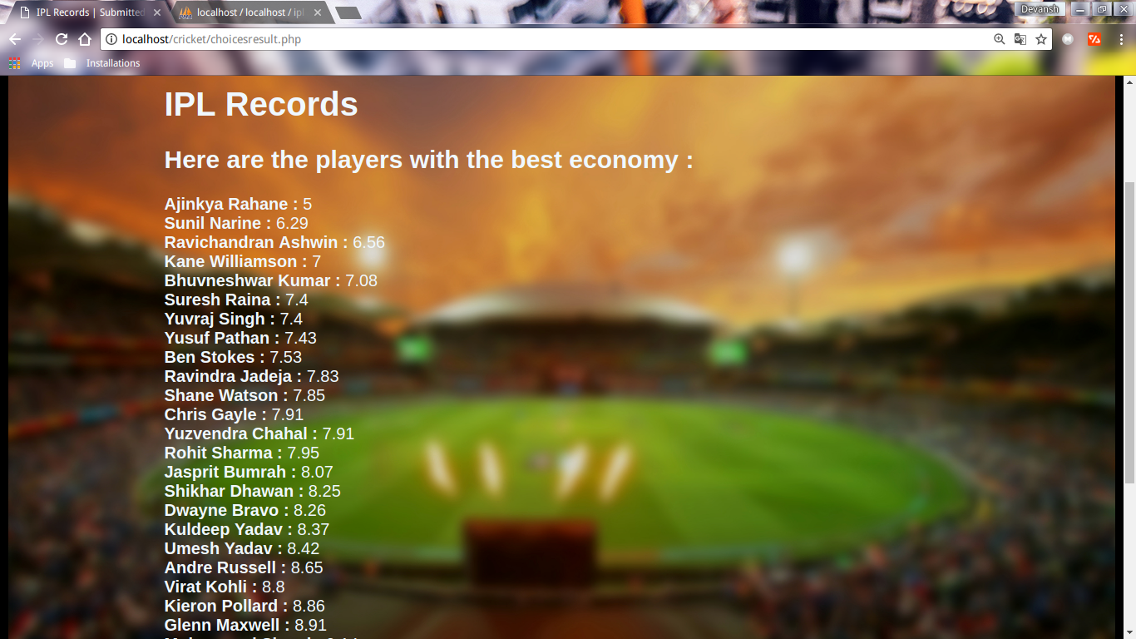

1. Who are the players with the best bowling strike rate?

SQL Query: SELECT first_name, last_name, ball/wicket AS strike_rate FROM player_bowling ORDER BY strike_rate ;

On running the query using the GUI, following result was obtained:

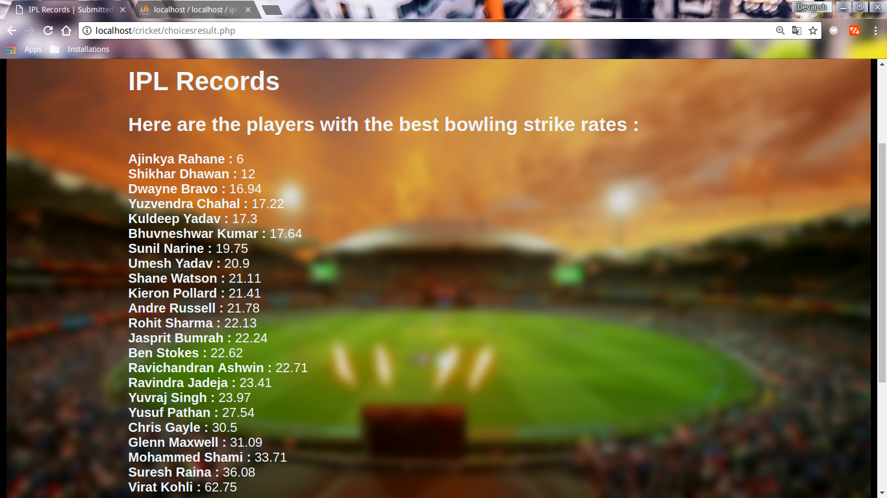

1. Who are the players with the most fifties?

SQL Query: SELECT first_name, last_name, fifty FROM player_batting ORDER BY fifty desc;

On running the query using the GUI, following result was obtained:

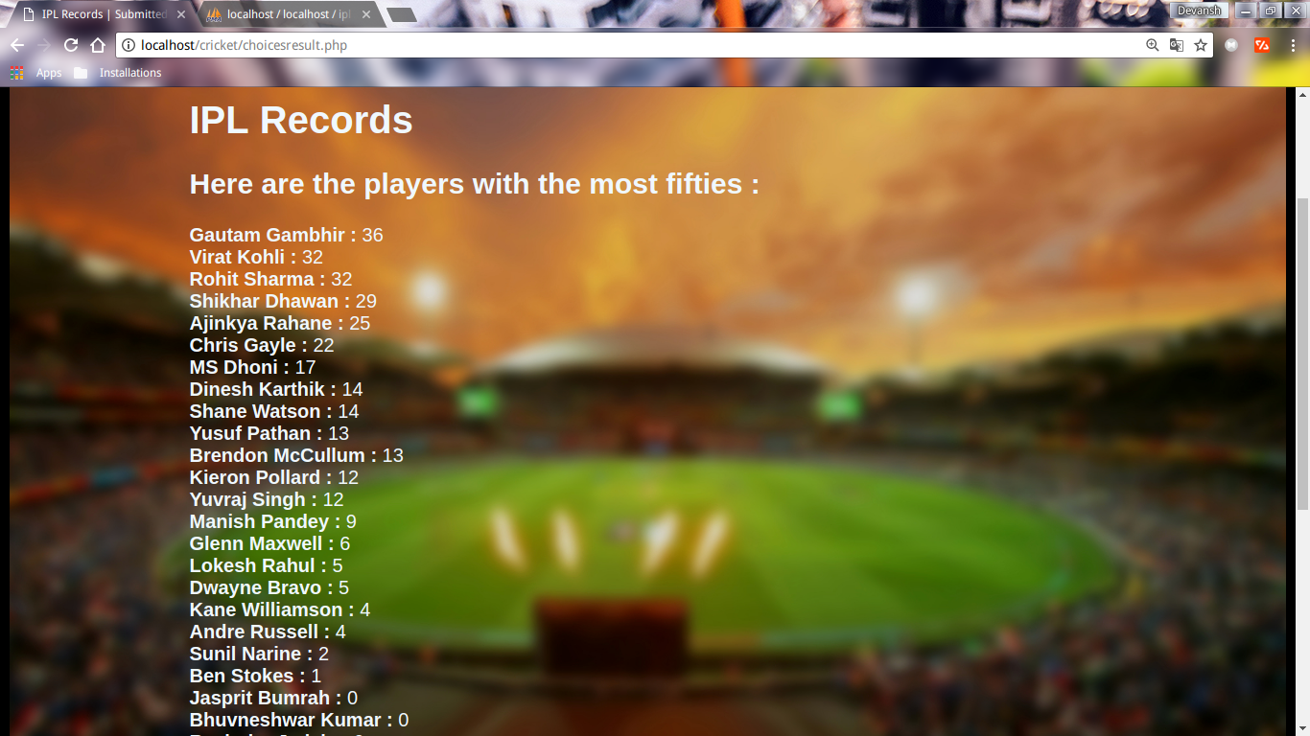

1. Who are the players with the most hundreds?

SQL Query: SELECT first_name, last_name, hundred FROM player_batting ORDER BY hundred desc;

On running the query using the GUI, following result was obtained:

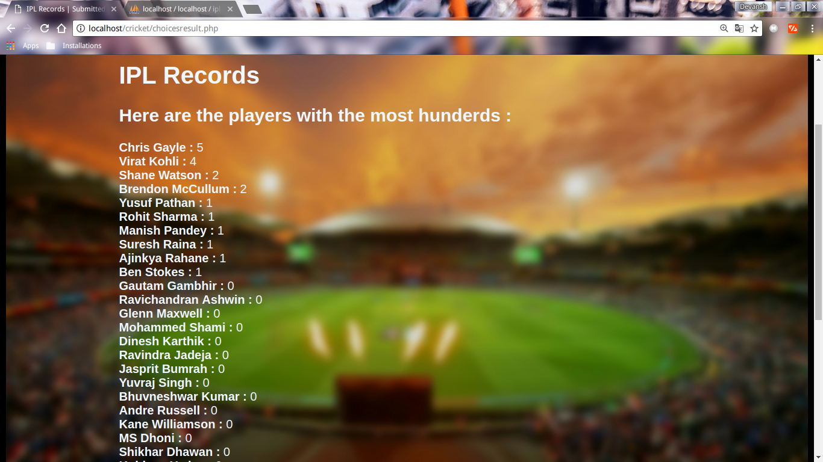

1. Who are the players with the highest score in an innings?

SQL Query: SELECT first_name, last_name, highscore FROM player_batting ORDER BY highscore desc;

On running the query using the GUI, following result was obtained:

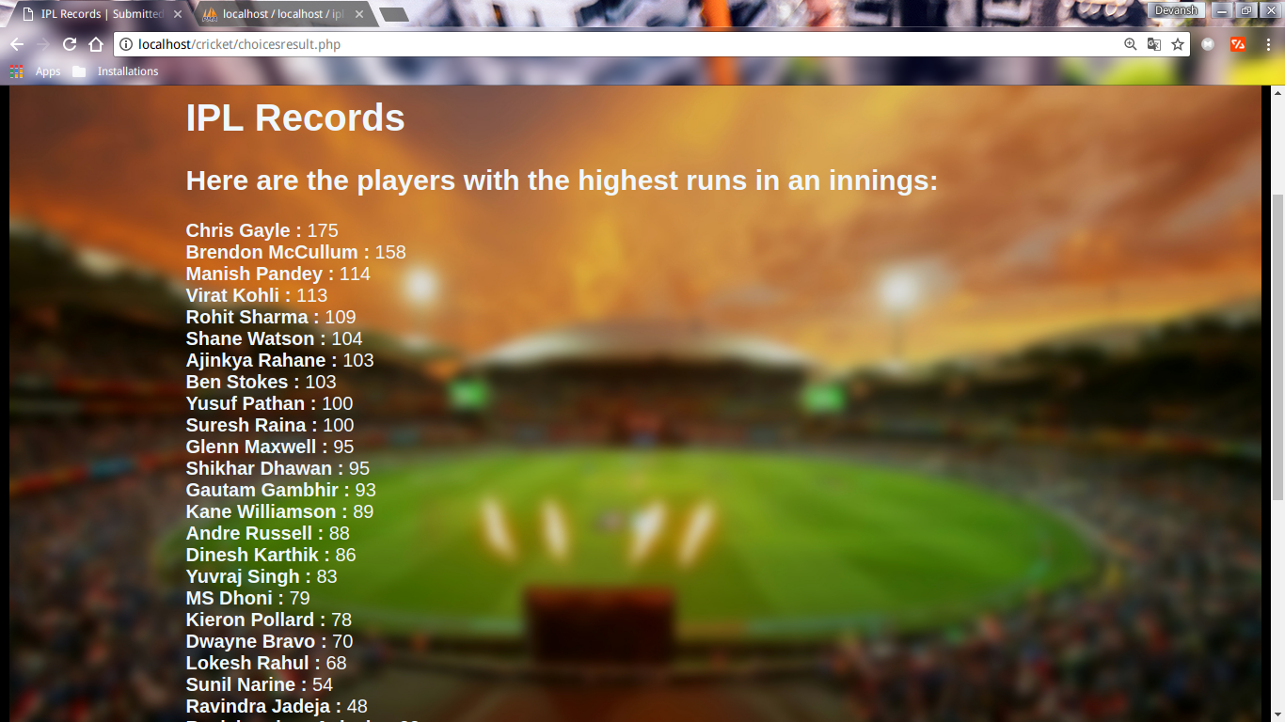

1. To view the complete profile of a player.

SQL Query:

SELECT * FROM player_personal WHERE first_name = '$first_name' AND last_name = '$last_name';

SELECT * FROM player_batting WHERE first_name = '$first_name' AND last_name = '$last_name';

SELECT * FROM player_bowling WHERE first_name = '$first_name' AND last_name = '$last_name';

To view the complete stats, several figures like strike_rate, economy, average etc. are calculated from the values returned from the database, and then displayed.

On running the query using the GUI, with $first_name = “Virat” and $last_name = “Kohli”, following result was obtained:

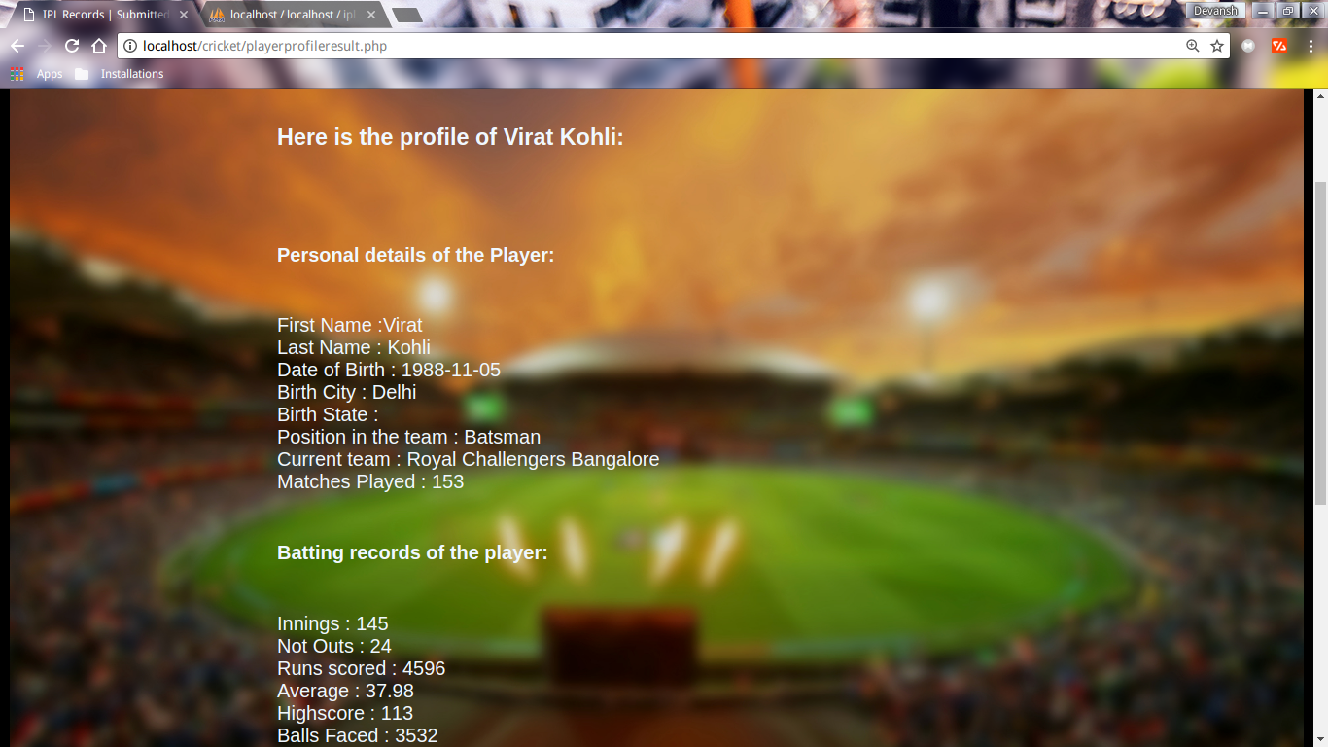

**Populating the tables:**

Run the following queries to populate the database tables:

**For table `player_batting`:**

INSERT INTO `player_batting` (`first_name`, `last_name`, `innings`, `not_out`, `runs_scored`, `highscore`, `ball_faced`, `hundred`, `double_hundred`, `fifty`, `four`, `six`) VALUES

('MS', 'Dhoni', 146, 50, 3629, 79, 2667, 0, 0, 17, 255, 158),

('Lokesh', 'Rahul', 33, 6, 860, 68, 645, 0, 0, 5, 76, 32),

('Shane', 'Watson', 101, 14, 2691, 104, 1933, 2, 0, 14, 263, 126),

('Dwayne', 'Bravo', 86, 30, 1342, 70, 1035, 0, 0, 5, 106, 56),

('Virat', 'Kohli', 145, 24, 4596, 113, 3532, 4, 0, 32, 400, 164),

('Rohit', 'Sharma', 157, 25, 4251, 109, 3257, 1, 0, 32, 358, 174),

('Kieron', 'Pollard', 115, 32, 2371, 78, 1623, 0, 0, 12, 160, 149),

('Umesh', 'Yadav', 25, 18, 94, 24, 90, 0, 0, 0, 8, 3),

('Yuzvendra', 'Chahal', 10, 7, 15, 4, 28, 0, 0, 0, 0, 0),

('Ajinkya', 'Rahane', 108, 14, 3151, 103, 2608, 1, 0, 25, 333, 61),

('Sunil', 'Narine', 36, 12, 343, 54, 221, 0, 0, 2, 41, 19),

('Ben', 'Stokes', 14, 1, 364, 103, 262, 1, 0, 1, 25, 17),

('Kuldeep', 'Yadav', 2, 0, 20, 16, 22, 0, 0, 0, 2, 0),

('Chris', 'Gayle', 101, 12, 3689, 175, 2431, 5, 0, 22, 301, 269),

('Shikhar', 'Dhawan', 129, 18, 3690, 95, 3014, 0, 0, 29, 423, 72),

('Ravichandran', 'Ashwin', 39, 15, 278, 33, 272, 0, 0, 0, 25, 4),

('Kane', 'Williamson', 18, 3, 503, 89, 401, 0, 0, 4, 43, 13),

('Suresh', 'Raina', 159, 24, 4558, 100, 3283, 1, 0, 0, 402, 174),

('Andre', 'Russell', 29, 4, 727, 88, 395, 0, 0, 4, 51, 56),

('Gautam', 'Gambhir', 152, 16, 4211, 93, 3381, 0, 0, 36, 491, 59),

('Glenn', 'Maxwell', 59, 7, 1305, 95, 787, 0, 0, 6, 101, 88),

('Mohammed', 'Shami', 14, 6, 53, 21, 51, 0, 0, 0, 5, 2),

('Dinesh', 'Karthik', 138, 18, 3012, 86, 2396, 0, 0, 14, 296, 74),

('Ravindra', 'Jadeja', 112, 38, 1774, 48, 1442, 0, 0, 0, 127, 59),

('Jasprit', 'Bumrah', 8, 6, 29, 16, 31, 0, 0, 0, 1, 1),

('Yuvraj', 'Singh', 119, 15, 2623, 83, 2011, 0, 0, 12, 209, 142),

('Brendon', 'McCullum', 106, 5, 2800, 158, 2130, 2, 0, 13, 284, 126),

('Manish', 'Pandey', 98, 18, 2230, 114, 1863, 1, 0, 9, 197, 64),

('Yusuf', 'Pathan', 135, 36, 2935, 100, 2017, 1, 0, 13, 243, 147),

('Bhuvneshwar', 'Kumar', 34, 15, 158, 24, 157, 0, 0, 0, 15, 3);

----------------------------------------------------------

**For table `player_bowling`:**

INSERT INTO `player_bowling` (`first_name`, `last_name`, `innings`, `ball`, `runs_given`, `wicket`, `fifer`, `tenfer`) VALUES

('MS', 'Dhoni', 0, 0, 0, 0, 0, 0),

('Lokesh', 'Rahul', 0, 0, 0, 0, 0, 0),

('Shane', 'Watson', 97, 1921, 2514, 91, 0, 0),

('Dwayne', 'Bravo', 106, 2083, 2867, 123, 0, 0),

('Virat', 'Kohli', 26, 251, 368, 4, 0, 0),

('Rohit', 'Sharma', 30, 332, 440, 15, 0, 0),

('Kieron', 'Pollard', 81, 1199, 1770, 56, 0, 0),

('Umesh', 'Yadav', 96, 2006, 2816, 96, 0, 0),

('Yuzvendra', 'Chahal', 58, 1257, 1658, 73, 0, 0),

('Ajinkya', 'Rahane', 1, 6, 5, 1, 0, 0),

('Sunil', 'Narine', 85, 2015, 2113, 102, 1, 0),

('Ben', 'Stokes', 14, 294, 369, 13, 0, 0),

('Kuldeep', 'Yadav', 18, 398, 555, 23, 0, 0),

('Chris', 'Gayle', 37, 549, 724, 18, 0, 0),

('Shikhar', 'Dhawan', 6, 48, 66, 4, 0, 0),

('Ravichandran', 'Ashwin', 111, 2362, 2584, 104, 0, 0),

('Kane', 'Williamson', 1, 6, 7, 0, 0, 0),

('Suresh', 'Raina', 68, 902, 1112, 25, 0, 0),

('Andre', 'Russell', 38, 697, 1005, 32, 0, 0),

('Gautam', 'Gambhir', 0, 0, 0, 0, 0, 0),

('Glenn', 'Maxwell', 34, 342, 508, 11, 0, 0),

('Mohammed', 'Shami', 35, 708, 1078, 21, 0, 0),

('Dinesh', 'Karthik', 0, 0, 0, 0, 0, 0),

('Ravindra', 'Jadeja', 114, 1943, 2534, 83, 1, 0),

('Jasprit', 'Bumrah', 51, 1134, 1526, 51, 0, 0),

('Yuvraj', 'Singh', 72, 863, 1064, 36, 0, 0),

('Brendon', 'McCullum', 0, 0, 0, 0, 0, 0),

('Manish', 'Pandey', 0, 0, 0, 0, 0, 0),

('Yusuf', 'Pathan', 80, 1129, 1398, 41, 0, 0),

('Bhuvneshwar', 'Kumar', 92, 2029, 2395, 115, 1, 0);

**For table `player_personal`:**

--

INSERT INTO `player_personal` (`first_name`, `last_name`, `date_of_birth`, `birth_city`, `birth_state`, `position`, `team`, `match_played`) VALUES

('Ajinkya', 'Rahane', '1988-06-06', 'Ashwi-KD', 'Maharashtra', 'Batsman', 'Rajasthan Royals', 114),

('Andre', 'Russell', '1988-04-29', '', '', 'Bowling Allrounder', 'Kolkata Knight Riders', 38),

('Ben', 'Stokes', '1991-06-04', 'Canterbury', 'New Zealand', 'Bowling Allrounder', 'Rajasthan Royals', 15),

('Bhuvneshwar', 'Kumar', '1990-02-05', 'Meerut', 'Uttar Pradesh', 'Bowler', 'Sunrisers Hyderabad', 92),

('Brendon', 'McCullum', '1981-09-27', 'Dunedin', 'Otago', 'Wicketkeeper-Batsman', 'Chennai Super Kings', 106),

('Chris', 'Gayle', '1979-07-21', 'Kingston', 'Jamaica', 'Batsman', 'Kings XI Punjab', 102),

('Dinesh', 'Karthik', '1985-06-01', 'Chennai', 'Tamil Nadu', 'Wicketkeeper-Batsman', 'Kolkata Knight Riders', 156),

('Dwayne', 'Bravo', '1983-10-07', 'Santa Cruz', 'Trinidad', 'Batting Allrounder', 'Chennai Super Kings', 109),

('Gautam', 'Gambhir', '1981-10-14', 'Delhi', '', 'Batsman', 'Delhi Daredevils', 152),

('Glenn', 'Maxwell', '1988-10-14', 'Kew, Melbourne', 'Victoria', 'Batting Allrounder', 'Delhi Daredevils', 60),

('Jasprit', 'Bumrah', '1993-12-06', 'Ahmedabad', 'Gujarat', 'Bowler', 'Mumbai Indians', 51),

('Kane', 'Williamson', '1990-08-08', 'Tauranga', '', 'Batsman', 'Sunrisers Hyderabad', 18),

('Kieron', 'Pollard', '1987-05-12', 'Tacarigua', 'Trinidad', 'Batting Allrounder', 'Mumbai Indians', 126),

('Kuldeep', 'Yadav', '1994-12-14', 'Kanpur', 'Uttar Pradesh', 'Bowler', 'Kolkata Knight Riders', 19),

('Lokesh', 'Rahul', '1992-04-18', 'Mangaluru', 'Karnataka', 'Wicketkeeper-Batsman', 'Kings XI Punjab', 42),

('Manish', 'Pandey', '1989-10-10', 'Nainital', 'Uttarakhand', 'Batsman', 'Sunrisers Hyderabad', 106),

('Mohammed', 'Shami', '1990-02-09', 'Jonagar', 'West Bengal', 'Bowler', 'Delhi Daredevils', 35),

('MS', 'Dhoni', '1981-07-07', 'Ranchi', 'Jharkhand', 'Wicketkeeper-Batsman', 'Chennai Super Kings', 162),

('Ravichandran', 'Ashwin', '1986-09-17', '', '', 'Bowling Allrounder', 'Kings XI Punjab', 114),

('Ravindra', 'Jadeja', '1988-12-06', 'Navagam-Khed', 'Saurashtra', 'Bowling Allrounder', 'Chennai Super Kings', 141),

('Rohit', 'Sharma', '1987-04-30', 'Nagpur', 'Maharashtra', 'Batsman', 'Mumbai Indians', 162),

('Shane', 'Watson', '1981-06-17', 'Ipswich', 'Queensland', 'Batting Allrounder', 'Chennai Super Kings', 105),

('Shikhar', 'Dhawan', '1985-12-05', 'Delhi', '', 'Batsman', 'Sunrisers Hyderabad', 130),

('Sunil', 'Narine', '1988-06-26', 'Arima', 'Trinidad & Tobago', 'Bowler', 'Kolkata Knight Riders', 86),

('Suresh', 'Raina', '1986-11-27', 'Ghaziabad', 'Uttar Pradesh', 'Batsman', 'Chennai Super Kings', 163),

('Umesh', 'Yadav', '1987-10-25', '', '', 'Bowler', 'Royal Challengers Bangalore', 97),

('Virat', 'Kohli', '1988-11-05', 'Delhi', '', 'Batsman', 'Royal Challengers Bangalore', 153),

('Yusuf', 'Pathan', '1982-11-17', 'Baroda', 'Gujarat', 'Batting Allrounder', 'Sunrisers Hyderabad', 152),

('Yuvraj', 'Singh', '1981-12-12', 'Chandigarh', '', 'Batsman', 'Kings XI Punjab', 123),

('Yuzvendra', 'Chahal', '1990-07-23', 'Jind', 'Haryana', 'Bowler', 'Royal Challengers Bangalore', 59);